Kaiser mounting plate
Holes are on a rectagle 50 x 30 mm
I use Heat Set Inserts so the thread is M3

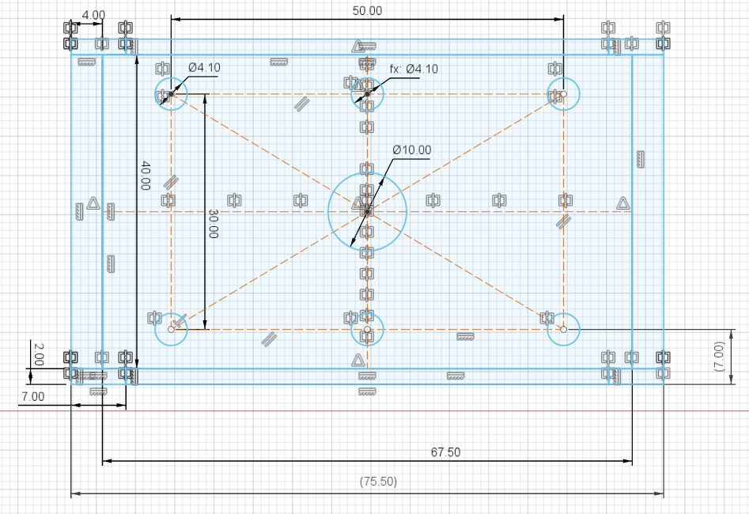

3D Rendering
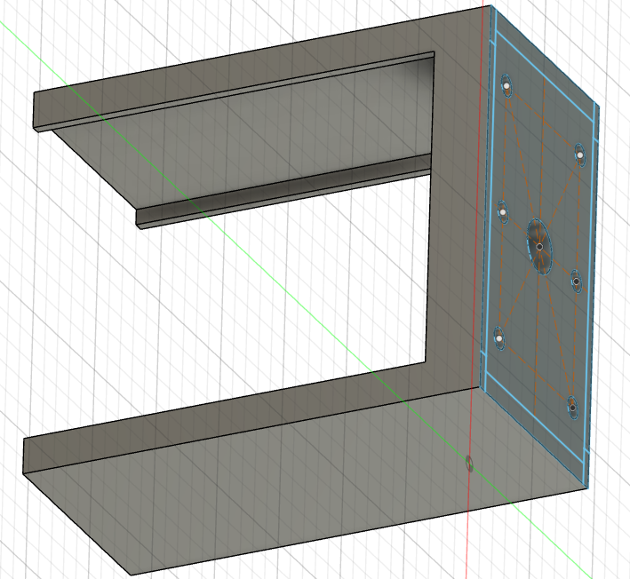

Printer layout
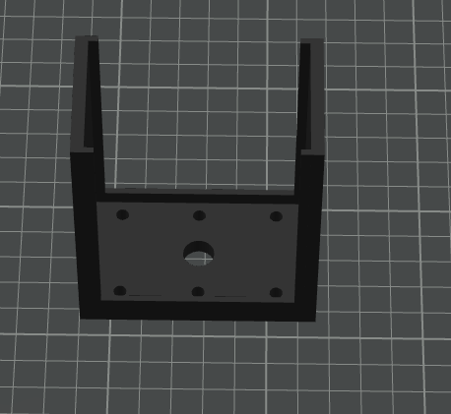

Images
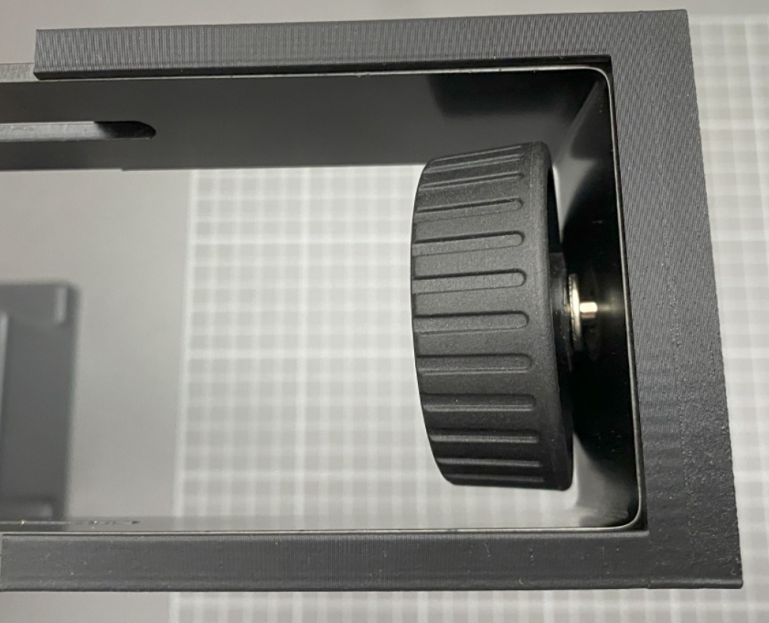 | 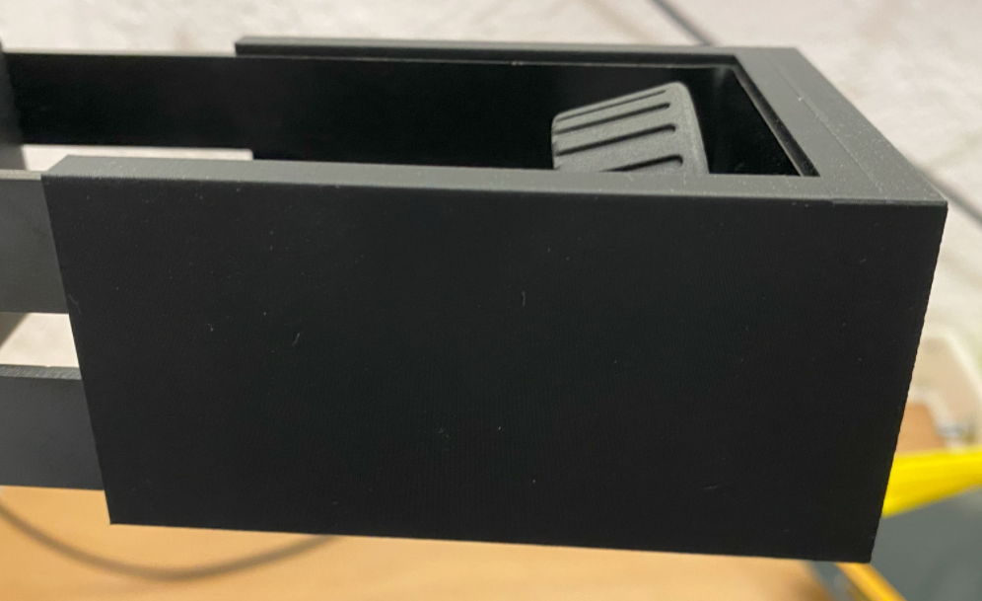
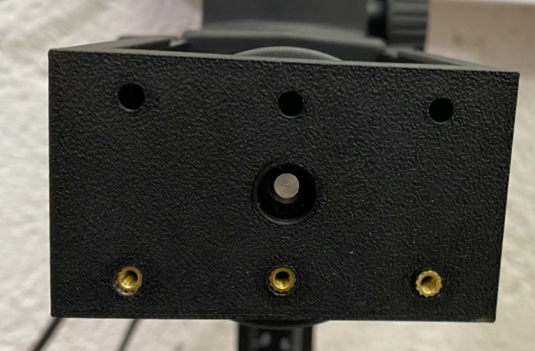

For the next Iteration
Add 4 holes for M3 insert on the side of the bracket using the thickness of the head
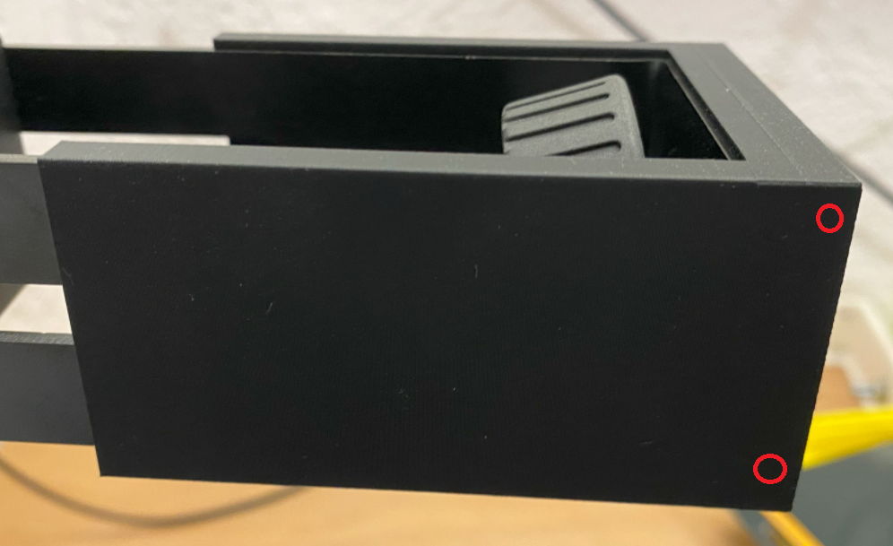

Add numbers to specify mounting distance
